Northern University of Business and Technology Khulna
Department of Computer Science and Engineering

Final Project Report

Project Title:
Maze Game

Submitted by:
Afia Anjum
11240321726

Course Title: Software Development I
Course Code: CSE 2216

Section: 4A

Submitted to:
Vashkar Kar
Lecturer,

Department of Computer Science and Engineering,
Northern University of Business and Technology Khulna

Date of Submission: 24 September, 2026
ACKNOWLEDGEMENT:
The successful completion of this project has been made possible through the guidance, support, and encouragement received throughout the development process.
I would like to express my sincere appreciation to Vashkor Kar, Lecturer, Department of Computer Science and Engineering, Northern University of Business and Technology, Khulna, for providing valuable guidance and academic direction throughout the project. His instructions and feedback contributed significantly to the planning, development, and completion of the project.
I would also like to acknowledge the Department of Computer Science and Engineering for providing the academic environment and necessary facilities required for carrying out the project.
Finally, I would like to express my gratitude to my family, classmates, and all those who provided support and encouragement during the development and testing of the project.

ABSTRACT:
This project presents the design and development of Maze Adventure, a Java-based desktop application developed as an interactive maze game. The primary objective of the project is to implement fundamental programming concepts, object-oriented design principles, event handling, and graphical user interface development within a practical application.
The system provides four difficulty levels: Easy, Medium, Hard, and Extra Hard, with each level containing a distinct maze structure and size. The player navigates through the maze using keyboard arrow keys while avoiding wall cells and attempting to reach the designated exit position. The application incorporates movement validation to ensure that the player remains within the maze boundaries and cannot move through wall cells.
Additional features include a real-time playing timer, movement counter, difficulty selection, restart functionality, game status indicators, and automatic detection of the winning condition. Upon reaching the exit, the system displays a completion notification containing the player's completion time and number of valid movements.
The application has been implemented using Java, Java Swing, and AWT. The source code is organized into separate classes for maze management, player management, graphical interface, and application execution. The completed system demonstrates the practical application of programming logic, arrays, conditional statements, event-driven programming, object-oriented concepts, and graphical user interface design.

Contents
CHAPTER 1: INTRODUCTION 5
CHAPTER 2 : SYSTEM ANALYSIS AND REQUIREMENTS 8
CHAPTER 3 : SYSTEM DESIGN 13
CHAPTER 4 : IMPLEMENTATION 18
CHAPTER 5 : TESTING AND RESULTS 23
CHAPTER 6: CONCLUSION AND FUTURE SCOPE 27
REFERENCES 29

CHAPTER 1: INTRODUCTION

1.1 Background:
Computer-based games provide an effective environment for applying programming concepts in an interactive manner. Maze-based games are particularly suitable for demonstrating logical decision-making, movement control, boundary validation, and graphical representation.
A maze game consists of a structured environment containing paths and obstacles through which a player must navigate to reach a specified destination. The implementation of such a system requires appropriate data representation, movement validation, event handling, and graphical rendering.
Maze Adventure was developed as a Java-based desktop application to demonstrate these concepts in a practical software project. The application provides a structured maze environment where the player begins from a predefined starting position and attempts to reach the designated exit without passing through wall cells.
The project also incorporates multiple difficulty levels, a timer, movement counter, restart functionality, and a graphical user interface. These features allow fundamental Java programming concepts to be integrated into a single interactive application.

1.2 Problem Statement
The development of an interactive maze game requires effective management of player movement, obstacle detection, boundary validation, game status, and completion conditions. A maze application must ensure that the player can navigate through valid paths while preventing movement through walls or outside the defined game area.
The primary problem addressed by this project is the development of a desktop-based maze game that allows controlled navigation through predefined maze structures. The system must validate every movement, maintain the player's position, provide different levels of difficulty, and determine whether the player has successfully reached the designated exit.
In addition, the application should provide appropriate gameplay information, including elapsed time and number of valid movements. A restart mechanism is also required to allow the player to begin a new attempt.
Therefore, the project focuses on implementing these requirements through Java programming, object-oriented design, keyboard event handling, two-dimensional arrays, and graphical user interface components.

1.3 Objectives
The major objectives of the Maze Adventure project are:
- To design and develop a functional desktop-based maze game using Java.
- To represent maze structures using two-dimensional arrays.
- To implement keyboard-based player movement through event handling.
- To prevent the player from moving through wall cells.
- To prevent movement outside the defined maze boundaries.
- To provide four difficulty levels: Easy, Medium, Hard, and Extra Hard.
- To implement a timer for measuring gameplay duration.
- To implement a movement counter for recording valid movements.
- To provide a restart mechanism for resetting the game state.
- To detect successful completion when the player reaches the designated exit.
- To develop an interactive graphical user interface using Java Swing and AWT.
- To apply object-oriented programming and event-driven programming concepts in a practical application.

1.4 Scope of the Project
The scope of Maze Adventure includes the development of a desktop-based maze game with predefined maze layouts and multiple difficulty levels. The application allows a player to select a difficulty level and navigate the corresponding maze using keyboard arrow keys.
The system provides movement validation, wall collision prevention, boundary checking, gameplay timing, movement counting, restart functionality, and automatic detection of the winning condition. The graphical interface provides visual representations of the maze, starting point, exit point, and player.
The current implementation focuses on single-player desktop gameplay. The maze layouts are predefined within the application, and the project does not include online multiplayer functionality, database-based score storage, or network-based gameplay.
1.5 Project Development Plan

Week | Main Activities
Week 1 | Planning and Requirement Analysis
Week 2 | System Design and Architecture
Week 3 | Environment Setup and Basic Framework
Week 4 | Maze Generation and Maze Structure
Week 5 | Player Movement and Collision Detection
Week 6 | Restart Functionality and Timer
Week 7 | User Interface Improvement and Move Counter
Week 8 | Difficulty Level Implementation
Week 9 | Testing and Refinement
Week 10 | Documentation and Final Submission

CHAPTER 2 : SYSTEM ANALYSIS AND REQUIREMENTS
2.1 Existing System
Traditional maze games generally provide a simple environment in which a player moves through a predefined maze to reach a particular destination. The maze is usually represented using paths and walls, and the player controls movement through keyboard or other input devices. In basic implementations, the primary objective is to navigate from a starting position to an exit while avoiding obstacles.
However, a basic maze game may provide limited interaction and gameplay features. It may contain only a single maze layout, limited difficulty options, and minimal information about the player's performance. In some simple implementations, features such as a gameplay timer, movement counter, restart functionality, and clear game status indicators may not be available.
Another limitation of a basic implementation is that movement validation may not be sufficiently organized. A complete maze system needs to prevent the player from moving through walls and outside the boundaries of the maze while maintaining the correct player position.
Therefore, there is a need for a more structured maze application that combines maze navigation with appropriate movement validation, multiple difficulty levels, gameplay monitoring, restart functionality, and an interactive graphical interface.

2.2 Proposed System
The proposed system, Maze Adventure, is a Java-based desktop maze game designed to provide an interactive and structured maze navigation experience. The system allows the player to select one of four difficulty levels: Easy, Medium, Hard, and Extra Hard. Each level contains a different maze structure and size, providing increasing levels of challenge.
The player begins from a predefined starting position and navigates through the maze using keyboard arrow keys. The system validates each movement before changing the player's position. A player is allowed to move only within the maze boundaries and through valid path cells, while movement into wall cells is prevented.
The proposed system also includes a gameplay timer and movement counter to provide information about the player's performance. A restart button and keyboard-based restart option allow the player to reset the current game and start a new attempt. The system continuously maintains the current game status and identifies successful completion when the player reaches the designated exit position.
The application is implemented using Java Swing and AWT for graphical user interface development and event handling. The project is organized into separate classes for maze management, player management, and game interface functionality. This structure improves code organization and demonstrates the practical application of object-oriented and event-driven programming concepts.
Overall, the proposed system provides a complete desktop-based maze gaming environment that integrates maze navigation, movement validation, difficulty selection, gameplay monitoring, restart functionality, and winning-condition detection within a single application.

2.3 Functional Requirements
The functional requirements describe the operations and features that the Maze Adventure system must provide to the user.

Table 2.1: Functional Requirements
ID | Functional Requirement
FR-01 | The system shall display the selected maze.
FR-02 | The system shall allow keyboard-based player movement.
FR-03 | The system shall prevent the player from moving through wall cells.
FR-04 | The system shall prevent the player from moving outside the maze boundaries.
FR-05 | The system shall provide four difficulty levels: Easy, Medium, Hard, and Extra Hard.
FR-06 | The system shall display a gameplay timer.
FR-07 | The system shall count valid player movements.
FR-08 | The system shall provide a restart button.
FR-09 | The system shall allow the game to be restarted using the R key.
FR-10 | The system shall detect when the player reaches the exit.
FR-11 | The system shall display a winning notification after successful completion.
FR-12 | The system shall display the current game status.

2.4 Non-Functional Requirements
The non-functional requirements describe the quality and operational characteristics of the Maze Adventure system.

Table 2.2: Non-Functional Requirements
Category | Requirement
Usability | The interface should be simple and easy to understand.
Performance | Player movement should respond quickly to keyboard input.
Reliability | The system should correctly validate player movement and game conditions.
Maintainability | The source code should be organized into separate classes and packages.
Responsiveness | The graphical interface should respond appropriately to user actions.
Compatibility | The application should run on a system with a compatible Java environment.
Simplicity | The game should provide clear controls and understandable gameplay information.

2.5 Hardware Requirements
The hardware requirements for running the Maze Adventure application are relatively moderate because the application is a lightweight Java-based desktop program.
Table 2.3: Hardware Requirements
Component | Minimum Requirement
Processor | Intel Core i3 or equivalent
RAM | 4 GB or above
Storage | At least 500 MB of available space
Display | Standard monitor
Keyboard | Standard keyboard
Mouse | Standard mouse

2.6 Software Requirements
The software requirements include the development environment, programming platform, and libraries used to develop and execute the application.

Table 2.4: Software Requirements
Software/Technology | Purpose
Java JDK | Application development and execution
NetBeans IDE | Development and project management
Java Swing | Graphical user interface development
Java AWT | Graphics, colors, and event handling
Operating System | Running the desktop application

CHAPTER 3 : SYSTEM DESIGN

3.1 System Architecture
The system architecture of Maze Adventure represents the major components of the application and their interaction during gameplay. The application is organized into separate components for application execution, graphical interface management, maze management, and player management.
The Main class is responsible for launching the application window. The GamePanel class manages the graphical user interface, keyboard events, game timer, movement counter, difficulty selection, restart functionality, and overall game state. The Maze class stores the maze structure, difficulty-specific maze data, and the starting and exit positions. The Player class maintains the current row and column position of the player.
The components work together to provide a complete maze gaming environment. The GamePanel communicates with the Maze and Player classes to update and display the current game state.
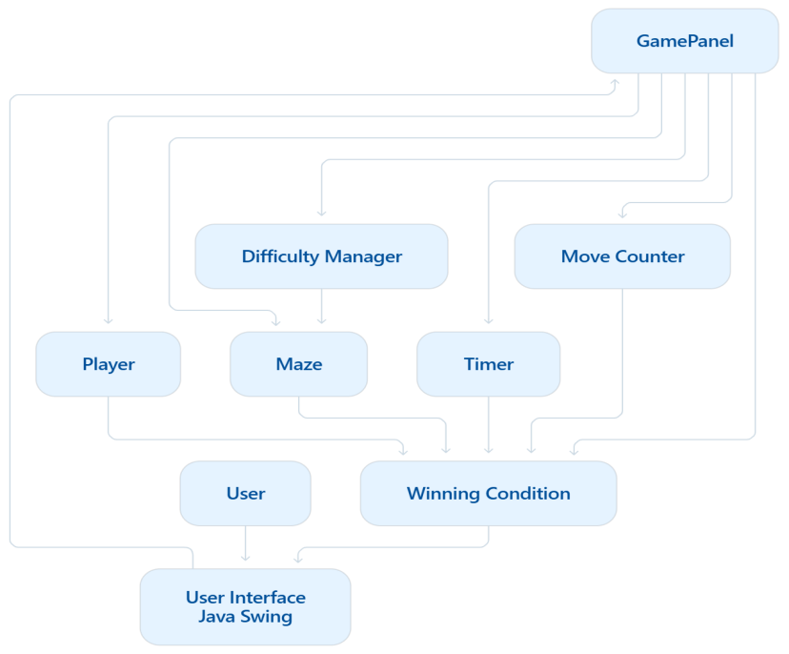
Figure 3.1: System Architecture
3.2 Use Case Diagram
The use case diagram represents the main interactions between the player and the Maze Adventure system. The player is the primary actor who interacts with the game by selecting a difficulty level, starting the game, controlling the player, restarting the game, monitoring gameplay information, and reaching the exit.
The major use cases of the system include selecting difficulty, starting the game, moving the player, viewing the timer, viewing the move count, restarting the game, and completing the maze.

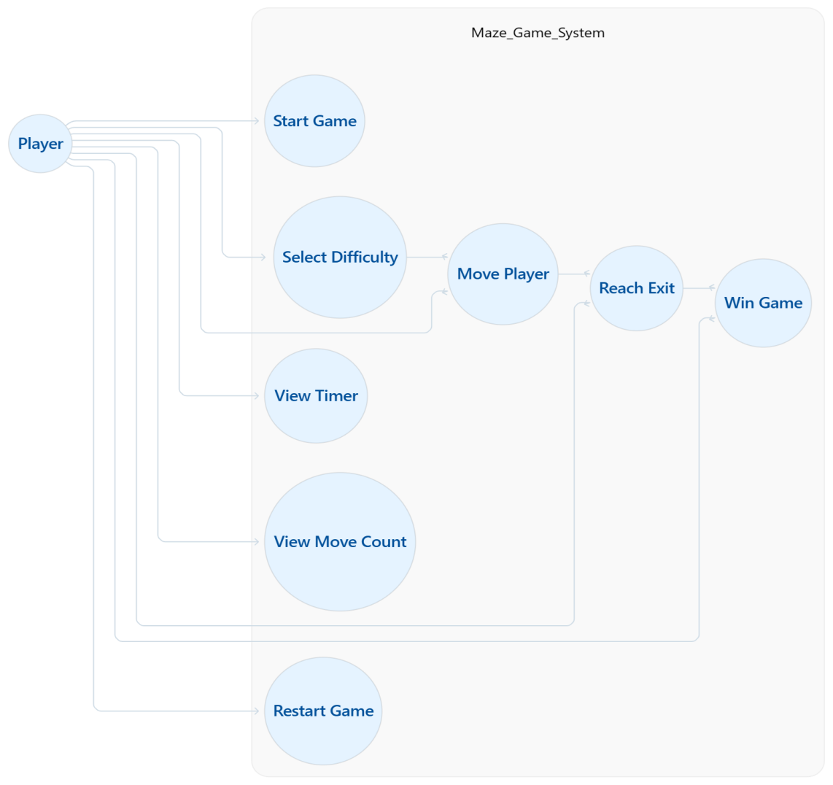
Figure 3.2: Use Case Diagram
3.3 System Flowchart
The system flowchart describes the sequence of major operations performed during gameplay. The process begins when the application is launched. The player selects a difficulty level, after which the corresponding maze is loaded. The player then provides keyboard input to move through the maze.
Before each movement, the system checks whether the requested position is within the maze boundaries and whether the destination cell is a valid path. If the movement is valid, the player's position is updated and the move counter is increased. If the player reaches the exit position, the system displays the winning state. Otherwise, the player continues navigating the maze.
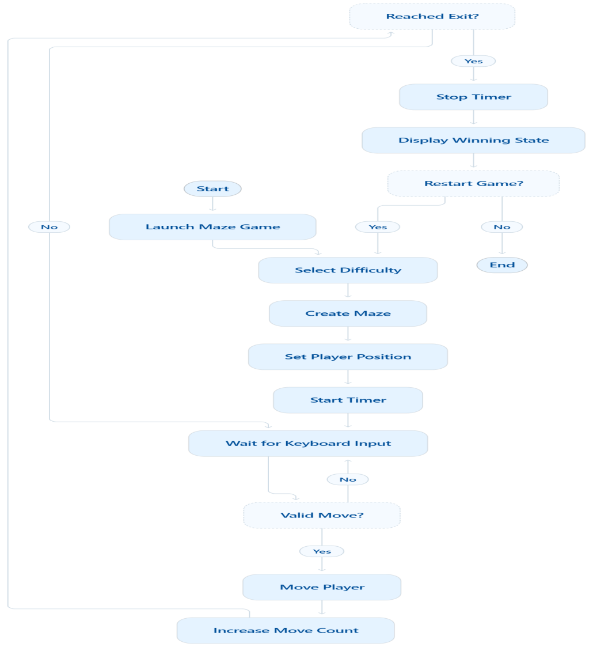
Figure 3.3: System Flowchart
3.4 Class Diagram
The class diagram represents the main classes used in the Maze Adventure application and their responsibilities.
The Main class starts the application and creates the main game window. The GamePanel class manages the main game interface and gameplay operations. The Maze class stores maze data and provides information about the maze dimensions, cells, starting position, and exit position. The Player class stores and updates the player's current position.
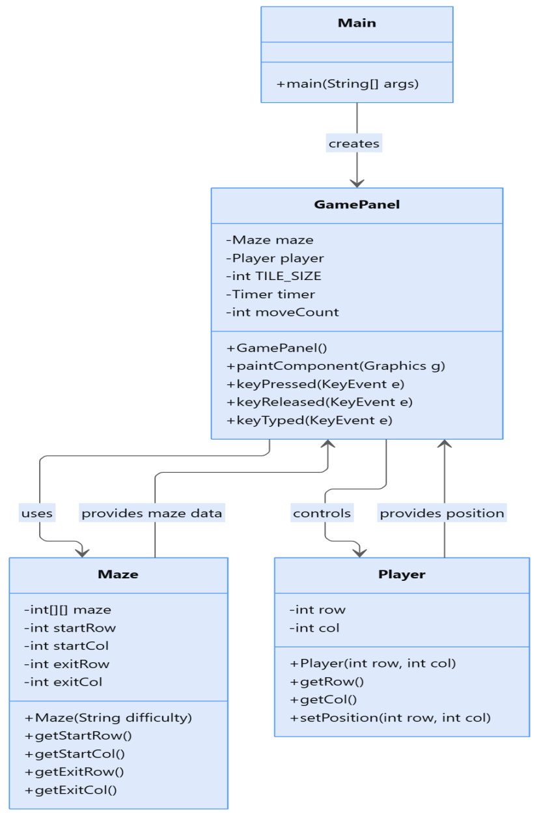
Figure 3.4: Class Diagram
3.5 Data Representation
The maze is represented using a two-dimensional integer array. Each element of the array represents a cell of the maze.
A value of 1 represents a wall cell, while a value of 0 represents a valid path cell. The row and column indexes are used to identify the location of each cell. The starting position and exit position are stored separately within the Maze class.
The Player class stores the current row and column position of the player. During gameplay, these values are updated whenever the player makes a valid movement.
This representation provides a simple and efficient method for storing and processing the maze structure.
3.6 User Interface Design
The graphical user interface is designed using Java Swing and AWT. The interface provides the maze display, difficulty selection, timer, move counter, game status, restart button, and keyboard-based controls.
The maze is visually represented using different colors for wall cells, path cells, the player, starting position, and exit position. The interface also provides visual feedback regarding the current state of the game.
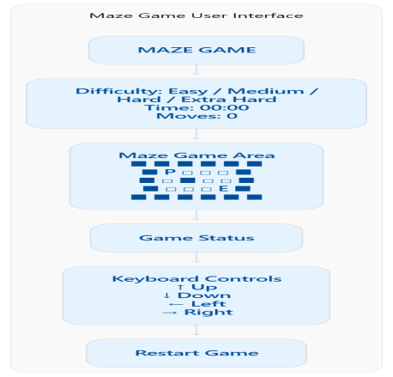
Figure 3.5: User Interface Design

CHAPTER 4 : IMPLEMENTATION
4.1 Development Environment
The Maze Adventure project was developed using the Java programming language. NetBeans IDE was used as the primary development environment for creating, organizing, compiling, and testing the application.
Java Swing and AWT were used to develop the graphical user interface and handle graphical components and keyboard events. The project follows a modular structure in which different classes are responsible for specific parts of the application.
4.2 Project Structure
The project is organized into separate packages and classes to maintain a clear and manageable source-code structure.
Maze Adventure
├── game
│ └── GamePanel.java
│
├── maze
│ └── Maze.java
│
├── player
│ └── Player.java
│
└── Main.java
The maze package contains the Maze class, which manages maze data and related information. The player package contains the Player class, which manages the player's position. The game package contains the GamePanel class, which manages the graphical interface and gameplay logic. The Main class is responsible for launching the application.
4.3 Maze Implementation
The Maze class is responsible for storing and managing the maze structures used by the application. The class contains maze data in a two-dimensional integer array and maintains the starting and exit positions.
The application supports four difficulty levels: Easy, Medium, Hard, and Extra Hard. When a difficulty level is selected, the corresponding maze structure is loaded into the application.
The Maze class also provides methods for obtaining the number of rows and columns, accessing individual maze cells, and retrieving the starting and exit positions.
4.4 Player Implementation
The Player class is responsible for maintaining the current position of the player within the maze. The position is represented using row and column values.
The class provides a constructor for setting the initial position and methods for retrieving and updating the player's row and column values.
The player initially starts from the predefined starting position of the selected maze. During gameplay, the position is updated only when a valid movement is performed.
4.5 Game Panel Implementation
The GamePanel class is the main component responsible for managing the graphical interface and gameplay operations.
It extends JPanel and implements KeyListener. The class displays the maze, player, starting point, and exit point. It also manages keyboard input, timer operations, movement counting, difficulty selection, restart functionality, game status, and winning detection.
The paintComponent() method is used to draw the current game state on the panel. Different graphical elements are drawn based on the values stored in the Maze and Player classes.
4.6 Player Movement and Collision Detection
Player movement is controlled through keyboard arrow keys. Before changing the player's position, the system checks whether the requested destination is valid.
The canMove() method performs two important validations. First, it checks whether the requested row and column are within the maze boundaries. Second, it checks whether the destination cell is a path cell.
The following logic prevents invalid movement:
if (newRow < 0 || newRow >= maze.getRows()
|| newCol < 0 || newCol >= maze.getCols()) {
return false;
}
return maze.getCell(newRow, newCol) == 0;
Therefore, the player cannot move outside the maze or through wall cells.

4.7 Difficulty Levels
Maze Adventure provides four difficulty levels. Each difficulty level uses a different maze size and structure.

Table 4.1: Difficulty Levels
Difficulty Level | Maze Size
Easy | 9 × 9
Medium | 15 × 15
Hard | 21 × 21
Extra Hard | 30 × 30

The difficulty selection is handled through the graphical user interface. When the user selects a different level, the corresponding maze is loaded and the player position is reset.

4.8 Timer and Move Counter
A gameplay timer is implemented to record the elapsed time during the current attempt. The timer begins when the player makes the first valid movement and stops when the game is completed or restarted.
The move counter records the number of valid player movements. Invalid movements, such as attempting to move into a wall or outside the maze, do not increase the move count.
These features provide the player with basic performance information during gameplay.

4.9 Winning Condition
The winning condition is checked after a valid movement. The system compares the player's new row and column with the predefined exit row and column of the selected maze.
The winning condition is represented by the following logic:
newRow == maze.getExitRow()
&& newCol == maze.getExitCol()
When both conditions are true, the system recognizes that the player has reached the exit. The game status changes to the winning state, the timer stops, and a completion notification is displayed.

4.10 Restart Functionality
The application provides a restart button and also supports restarting the game using the R key.
When the restart function is activated, the current timer is stopped, the selected maze is reloaded, the player's position is reset to the starting position, the move counter is reset, and the game status is returned to the initial state.
This allows the player to start a new attempt without closing and reopening the application.

4.11 Graphical User Interface
The graphical user interface is developed using Java Swing and AWT. It contains the maze display, difficulty selection control, timer display, move counter, game status indicator, and restart button.
The interface is designed to provide clear visual feedback and simple interaction. The maze is displayed dynamically according to the selected difficulty level. The tile size is calculated based on the available display area so that different maze sizes can be displayed within the game window.The interface also displays a winning state when the player successfully reaches the exit.

CHAPTER 5 : TESTING AND RESULTS
5.1 Testing Strategy
Testing was performed to verify that the major features of Maze Adventure operate according to the specified requirements. The testing process focused on application startup, difficulty selection, player movement, wall collision, boundary validation, timer operation, move counting, restart functionality, and winning-condition detection.
Both valid and invalid player movements were considered during testing. The application was also tested using the available difficulty levels to verify that the corresponding maze structures were loaded correctly.
5.2 Test Case
Table 5.1: Test Cases and Results
Test ID | Test Case | Expected Result | Result
TC-01 | Start application | Game window opens successfully | Pass
TC-02 | Select Easy difficulty | Easy maze is loaded | Pass
TC-03 | Select Medium difficulty | Medium maze is loaded | Pass
TC-04 | Select Hard difficulty | Hard maze is loaded | Pass
TC-05 | Select Extra Hard difficulty | Extra Hard maze is loaded | Pass
TC-06 | Move toward a wall | Player remains in the current position | Pass
TC-07 | Move outside boundary | Movement is prevented | Pass
TC-08 | Make a valid movement | Player moves to the valid cell | Pass
TC-09 | Make first valid movement | Timer starts | Pass
TC-10 | Make valid movements | Move counter increases | Pass
TC-11 | Click Restart | Game resets to initial state | Pass
TC-12 | Press R key | Game restarts | Pass
TC-13 | Reach exit | Winning state is displayed | Pass

5.3 Testing Results
The testing process confirmed that the major functional requirements of the Maze Adventure application were implemented successfully. The application loaded the selected difficulty level correctly and allowed the player to navigate through valid path cells.
The wall collision and boundary validation mechanisms prevented invalid movements. The timer and movement counter operated during gameplay, while the restart functionality successfully reset the game state.
The winning condition was also verified by reaching the designated exit position. After successful completion, the application displayed the appropriate winning state and completion information.
5.4 Screenshots of the Application
Easy Difficulty Level:
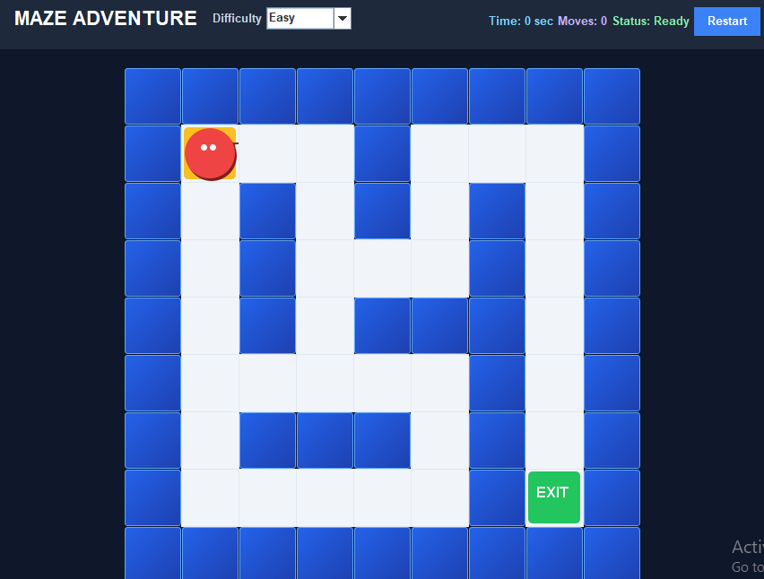
Figure 5.1: Easy Difficulty Level
Medium Difficulty Level:
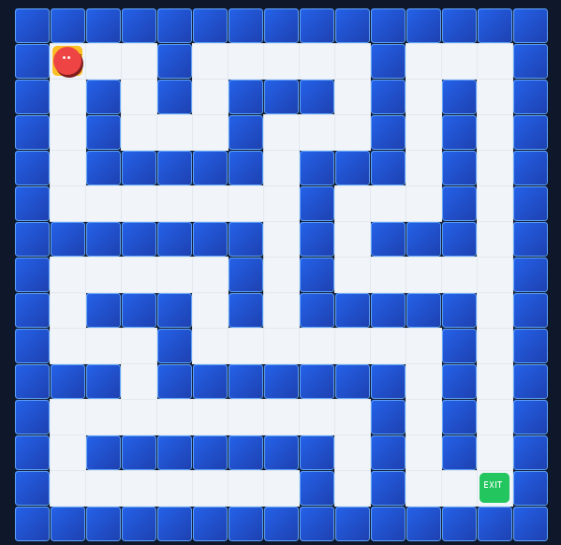
Figure 5.2: Medium Difficulty Level
Hard Difficulty Level:
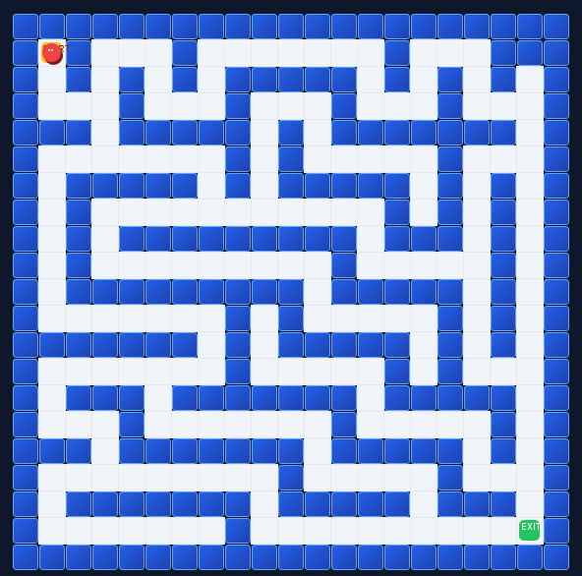
Figure 5.3: Hard Difficulty Level
Extra Hard Difficulty Level:
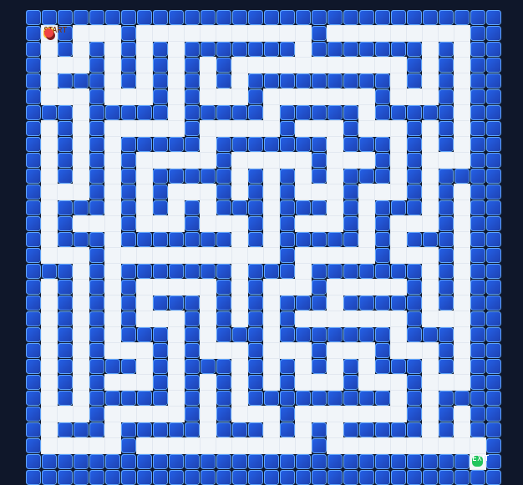
Figure 5.4: Extra Hard Difficulty Level
Winning State:
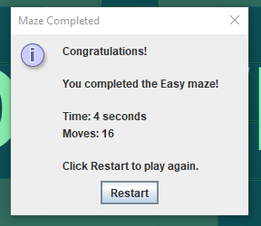
Figure 5.5: Winning State

5.5 Overall Result
The completed Maze Adventure application successfully implements the major requirements defined for the project. The system provides multiple difficulty levels, keyboard-based navigation, movement validation, wall collision prevention, boundary checking, a gameplay timer, movement counting, restart functionality, and winning-condition detection.
The testing results indicate that the implemented features operate according to their intended functionality. The project therefore demonstrates the practical application of Java programming, object-oriented programming, event-driven programming, graphical user interface development, arrays, conditional logic, and basic game-development concepts.

CHAPTER 6: CONCLUSION AND FUTURE SCOPE
6.1 Conclusion
Maze Adventure was successfully designed and implemented as a Java-based desktop maze game. The project provides an interactive environment in which a player can navigate through predefined maze structures using keyboard controls.
The application implements four difficulty levels, movement validation, wall collision prevention, boundary checking, a gameplay timer, movement counter, restart functionality, and automatic winning-condition detection. The graphical user interface provides clear visual representation of the maze and relevant gameplay information.
The project also provided practical experience in Java programming, object-oriented programming, event-driven programming, graphical user interface development, two-dimensional arrays, conditional statements, and basic software development practices.
Overall, the project achieved its primary objectives and resulted in a functional desktop-based maze game.
6.2 Limitations
Although the application provides the required gameplay features, some limitations remain in the current implementation.
- The maze layouts are predefined within the application.
- The application currently supports single-player gameplay.
- The system does not include online multiplayer functionality.
- The application does not use a database for storing scores or player records.
- The system does not currently generate mazes automatically using a maze-generation algorithm.
- The current version provides a basic graphical gaming experience without advanced animation and sound effects.
6.3 Future Scope
The Maze Adventure project can be further improved by adding additional features and technologies.
- Random maze generation can be implemented to create a different maze for each game session.
- A high-score system can be added to record the best completion times and move counts.
- Database integration can be introduced to store player information and game results.
- Sound effects and background music can be added to improve the gaming experience.
- Additional maze levels and difficulty modes can be developed.
- Multiplayer functionality can be introduced for competitive gameplay.
- Improved animations and graphical effects can be added to make the interface more interactive.
- The application can be extended to support additional platforms or technologies in the future.

REFERENCES
R. Rasala, J. Raab, and V. K. Proulx, “The SIGCSE 2001 Maze Demonstration Program,” ACM SIGCSE Bulletin, 2002. DOI: 10.1145/563517.563455. Available on ResearchGate: https://www.researchgate.net/publication/2541927_The_SIGCSE_2001_Maze_Demonstration_program
L. Stemkoski, “Maze Games,” in Java Game Development with LibGDX, pp. 311–333, 2018. DOI: 10.1007/978-1-4842-3324-5_14. Available on ResearchGate: https://www.researchgate.net/publication/322587367_Maze_Games

